**Classify images with the Microsoft Custom Vision Service**

Create, train and test a custom image classification model using the Custom Vision Service to accurately identify cars with variety of features

<https://docs.microsoft.com/en-gb/learn/modules/classify-images-with-custom-vision-service/>

**Introduction**

[Microsoft Cognitive Services](https://azure.microsoft.com/services/cognitive-services/) is a suite of services and APIs backed by machine learning that enables developers to incorporate intelligent features such as facial recognition in photos and videos, sentiment analysis in text, and language understanding into their applications. The Microsoft [Custom Vision Service](https://azure.microsoft.com/services/cognitive-services/custom-vision-service/) is among the newest members of the Cognitive Services suite. Its purpose is to create image classification models that "learn" from labeled images you provide. Want to know if a photo contains a picture of a flower? Train the Custom Vision Service with a collection of cars images, and it can tell you whether the next image is of same color and type— or even what brand of car it is.

## Learning objectives

In this module, you will:

* Create a Custom Vision Service project
* Train a Custom Vision Service model with tagged images
* Test a Custom Vision Service model
* Call your custom model's prediction endpoint over HTTP

**Test access to environment**

* Login to  <https://www.customvision.ai/projects> : In your web browser, navigate to the [Custom Vision web page](https://customvision.ai/) and select **Sign in**. Sign in with the same account you used to sign into the Azure portal.
* Create ‘New Project’ : To create your first project, select **New Project**. The **Create new project** dialog box will appear
* Enter a name and a description for the project. Then select a Resource Group. If your signed-in account is associated with an Azure account, the Resource Group dropdown will display all of your Azure Resource Groups that include a Custom Vision Service Resource.
* Select **Classification** under **Project Types**. Then, under **Classification Types**, choose either **Multilabel** or **Multiclass**
* Select domain **- General**
* Finally, select **Create project**.

**Exercise - Create a Custom Vision Service project**

* 5 minutes

The first step in building an image-classification model with the Custom Vision Service is to create a project. In this unit, you will use the Custom Vision Service portal to create a Custom Vision Service project.

1. Open the [Custom Vision Service portal](https://www.customvision.ai/) in your browser. Then select **Sign In**.
2. If you are asked to sign in, do so using the credentials for your Microsoft account. If you are asked to let this app access your info, click **Yes**, and if prompted, agree to the terms of service.
3. Click **New Project** to create a new project.

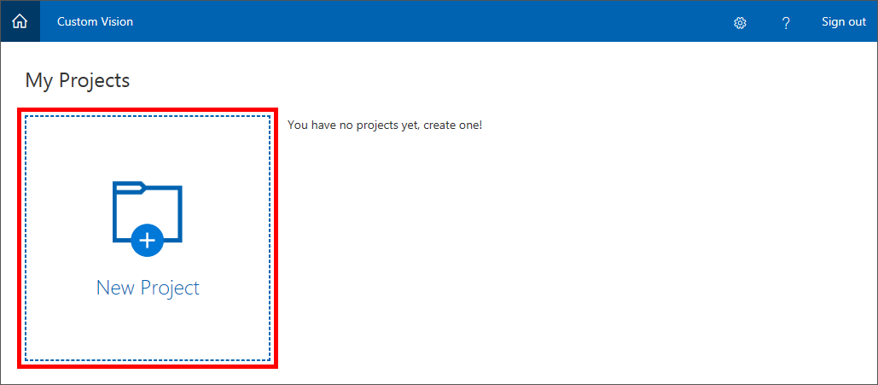

1. In the **Create new project** dialog, name the project Automobile.
2. Select the **Resource Group** you want to use for this project. If you do not already have a resource group, select **create new** to create a new resource group.
3. After you select the resource group, the following sections display:
   * **Project Types**: Select Classification.
   * **Classification Types**: Select **Multilabel**
   * **Domains**: Select **General**.

A domain optimizes a model for specific types of images. For example, if your goal is to classify food images by the types of food they contain or the ethnicity of the dishes, then it might be helpful to select the Food domain. For scenarios that don't match any of the offered domains, or if you are unsure of which domain to choose, select the General domain.

1. Select **Create project** to create our project.

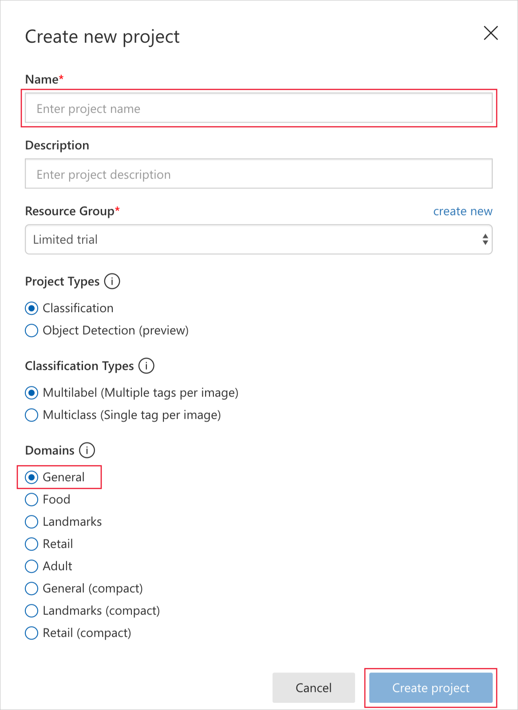

The next step is to upload images to the project and assign tags to those images to classify them.

**Exercise - Upload tagged images**

* 5 minutes

In this unit, you'll add images of cars to Automobile project. You'll tag the images so the Custom Vision Service can learn to differentiate one car from another.

1. In the **Automobile** project that we created, select the plus sign (**+**) to the right of **Tags** in the side panel.

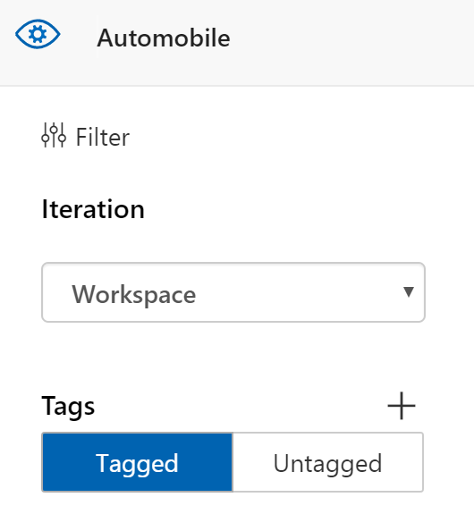

1. A dialog called **Create a new tag** is displayed. Type *Color:White* into the tag name field and select **Save**. This operation creates the tag *Color:White* in the tag list. Let's add some more.
2. Repeat steps 1 and 2 to add tags with the values Color:Green, Blue, and yellow. Also add tags for size SUV, Intermediate, Sports etc.The tag list will look like the following when you are finished.

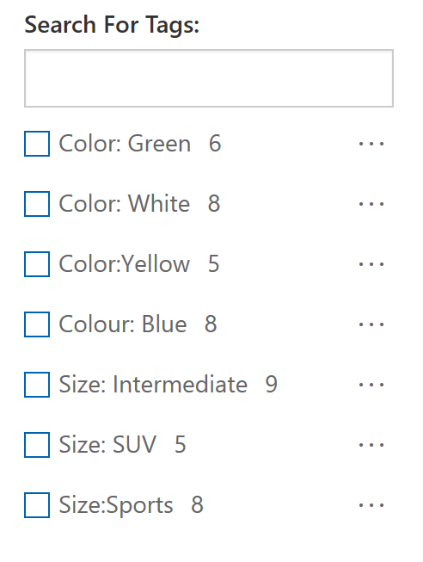

As you can see, the number of images in our project that are tagged with each of these tags is zero. Let's add some images to our project and assign tags.

1. Download [Cars Dataset](https://ai.stanford.edu/~jkrause/cars/car_dataset.html) which contains image resources for this module and unzip it to your local machine.
2. Back in the portal, select **Add images** to add images to the project.

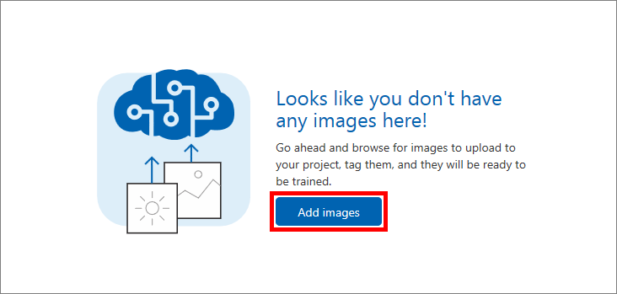

1. In the **cvs-resources** folder that you downloaded locally in step 4, navigate to the "Artists\Picasso" folder.
2. Select 10 files in "cars dataset" with White color, and then select **Open**.

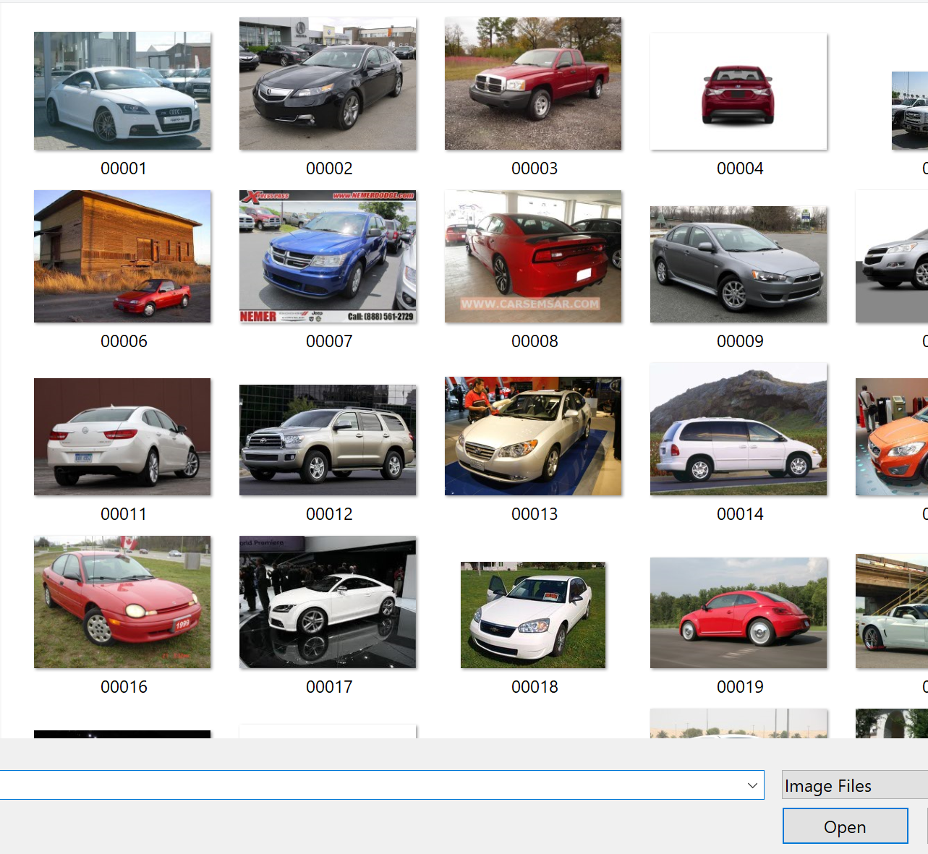

1. The **Image upload** dialog appears and displays thumbnails of all the images we are uploading. Select the **My Tags** field, which opens a dropdown of the tags you can assign these images.

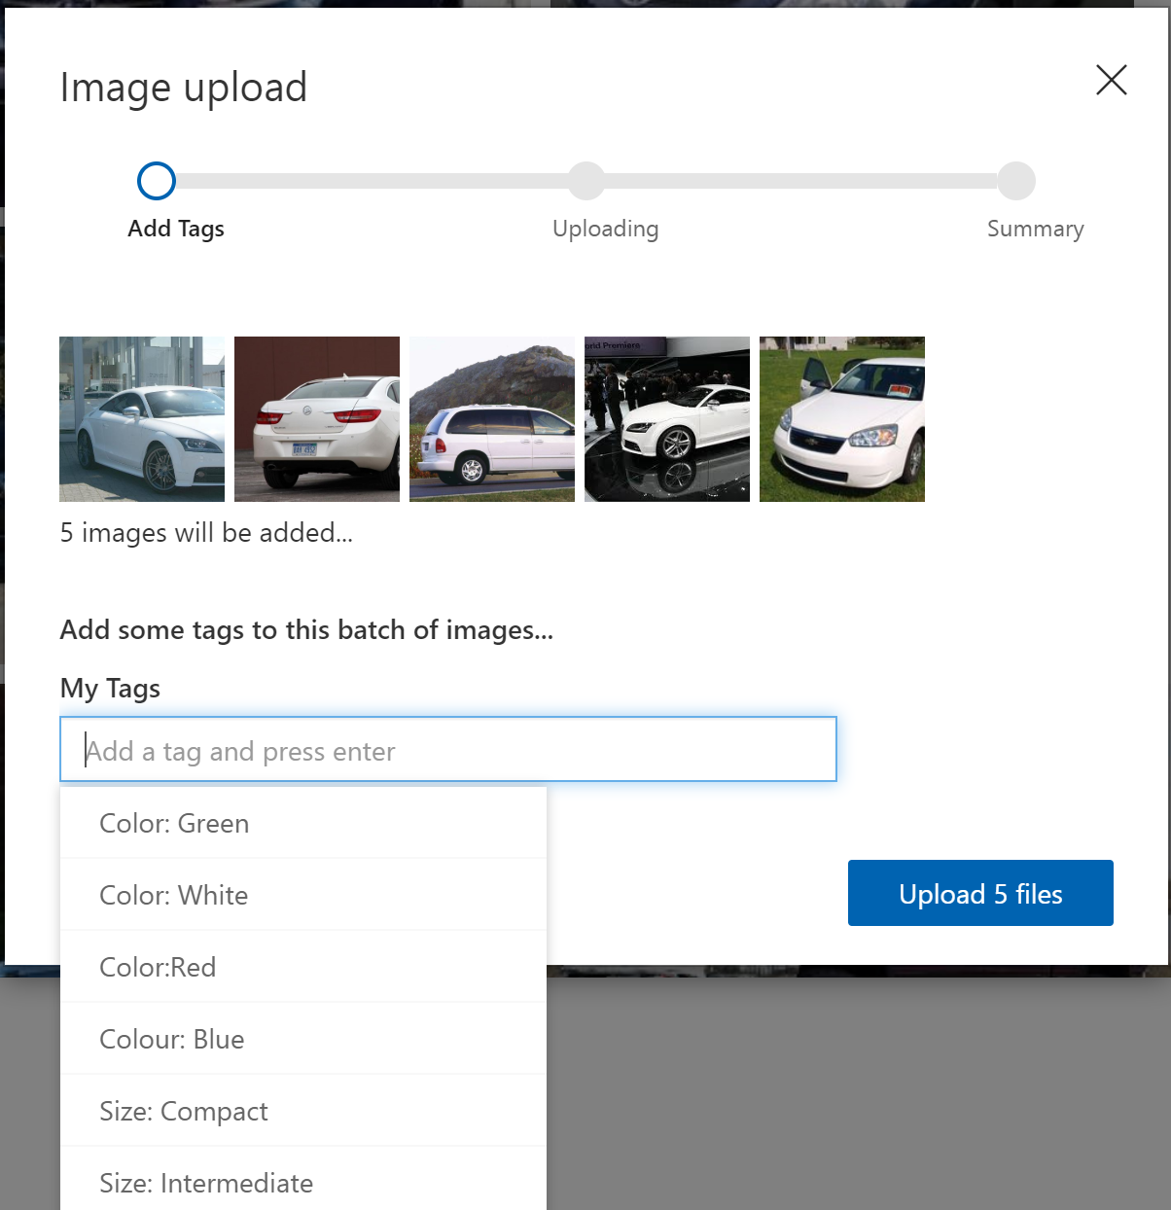

1. Select the tags Color:White and Picasso and then select **Upload 10 files** to finish the upload.
2. Confirm that the images you uploaded are now in the Automobile project, and that the tag list has been updated to show that we've tagged seven images with Color:White . Repeat the process for other tags in the project.

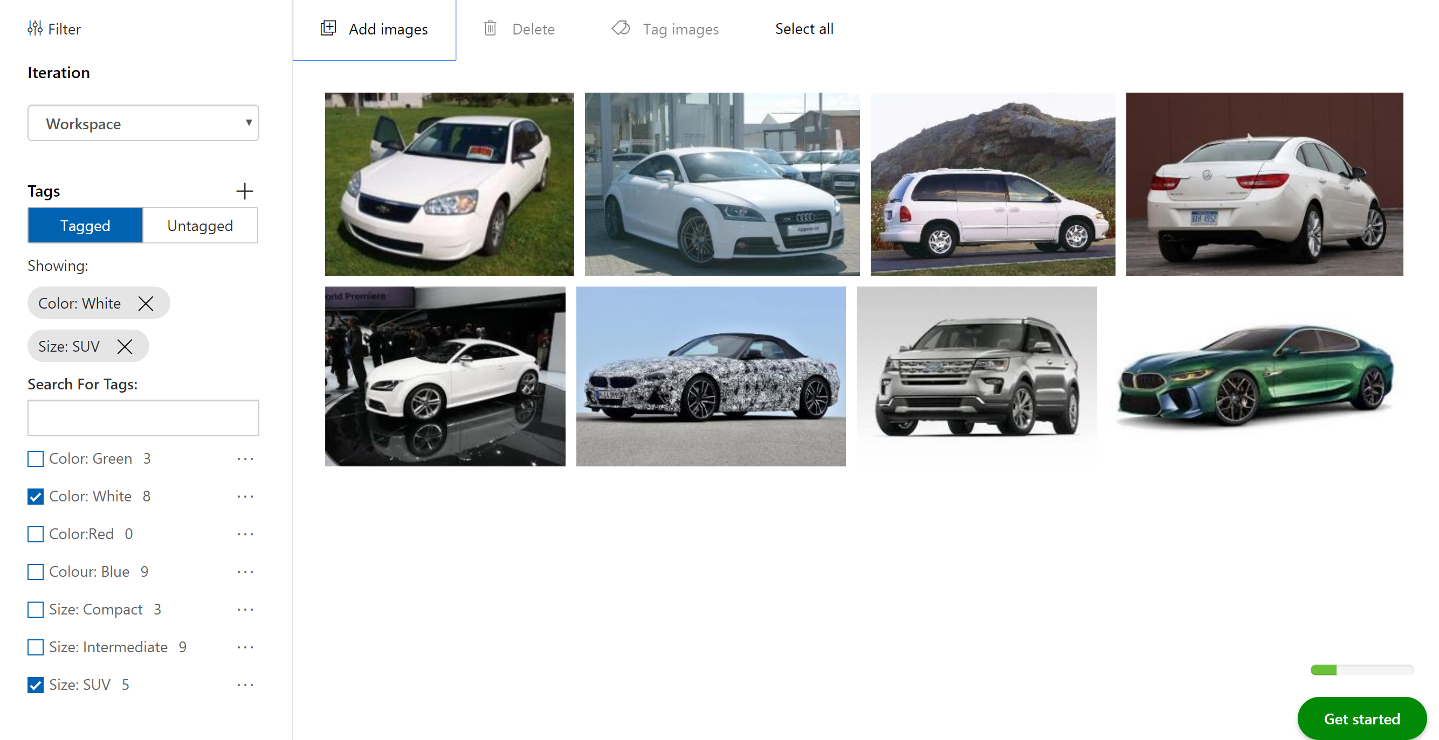

1. With five car images, the Custom Vision Service can do a decent job of identifying car by color and size . But if you trained the model right now, it would only understand what white or blue car looks like, and it wouldn't be able to identify cars by other colors or brands. The next step is to upload cars of other colors and tag them by brand name
2. Select **Add images** and select all of the images in the "cars" folder in the module resources. Tag them with the labels "color" and "brand" , and select **Upload 6 files** to upload them to the project.

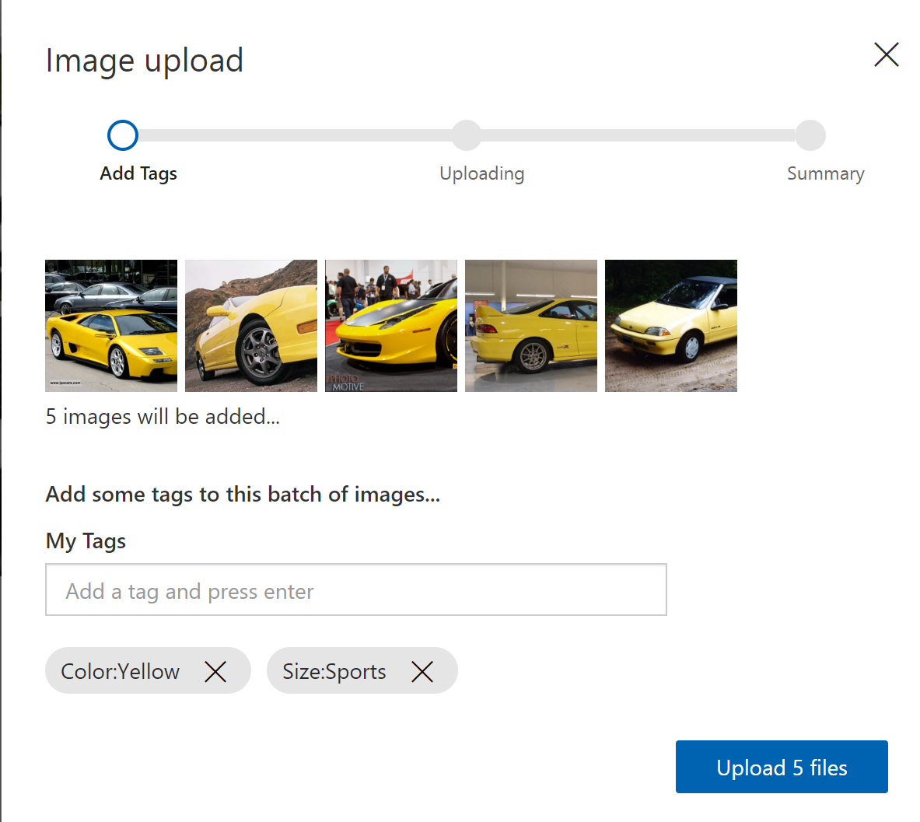

1. Confirm that the Yellow car images appear alongside the other images in the project, and that “Color:Yellow" appears in the list of tags.

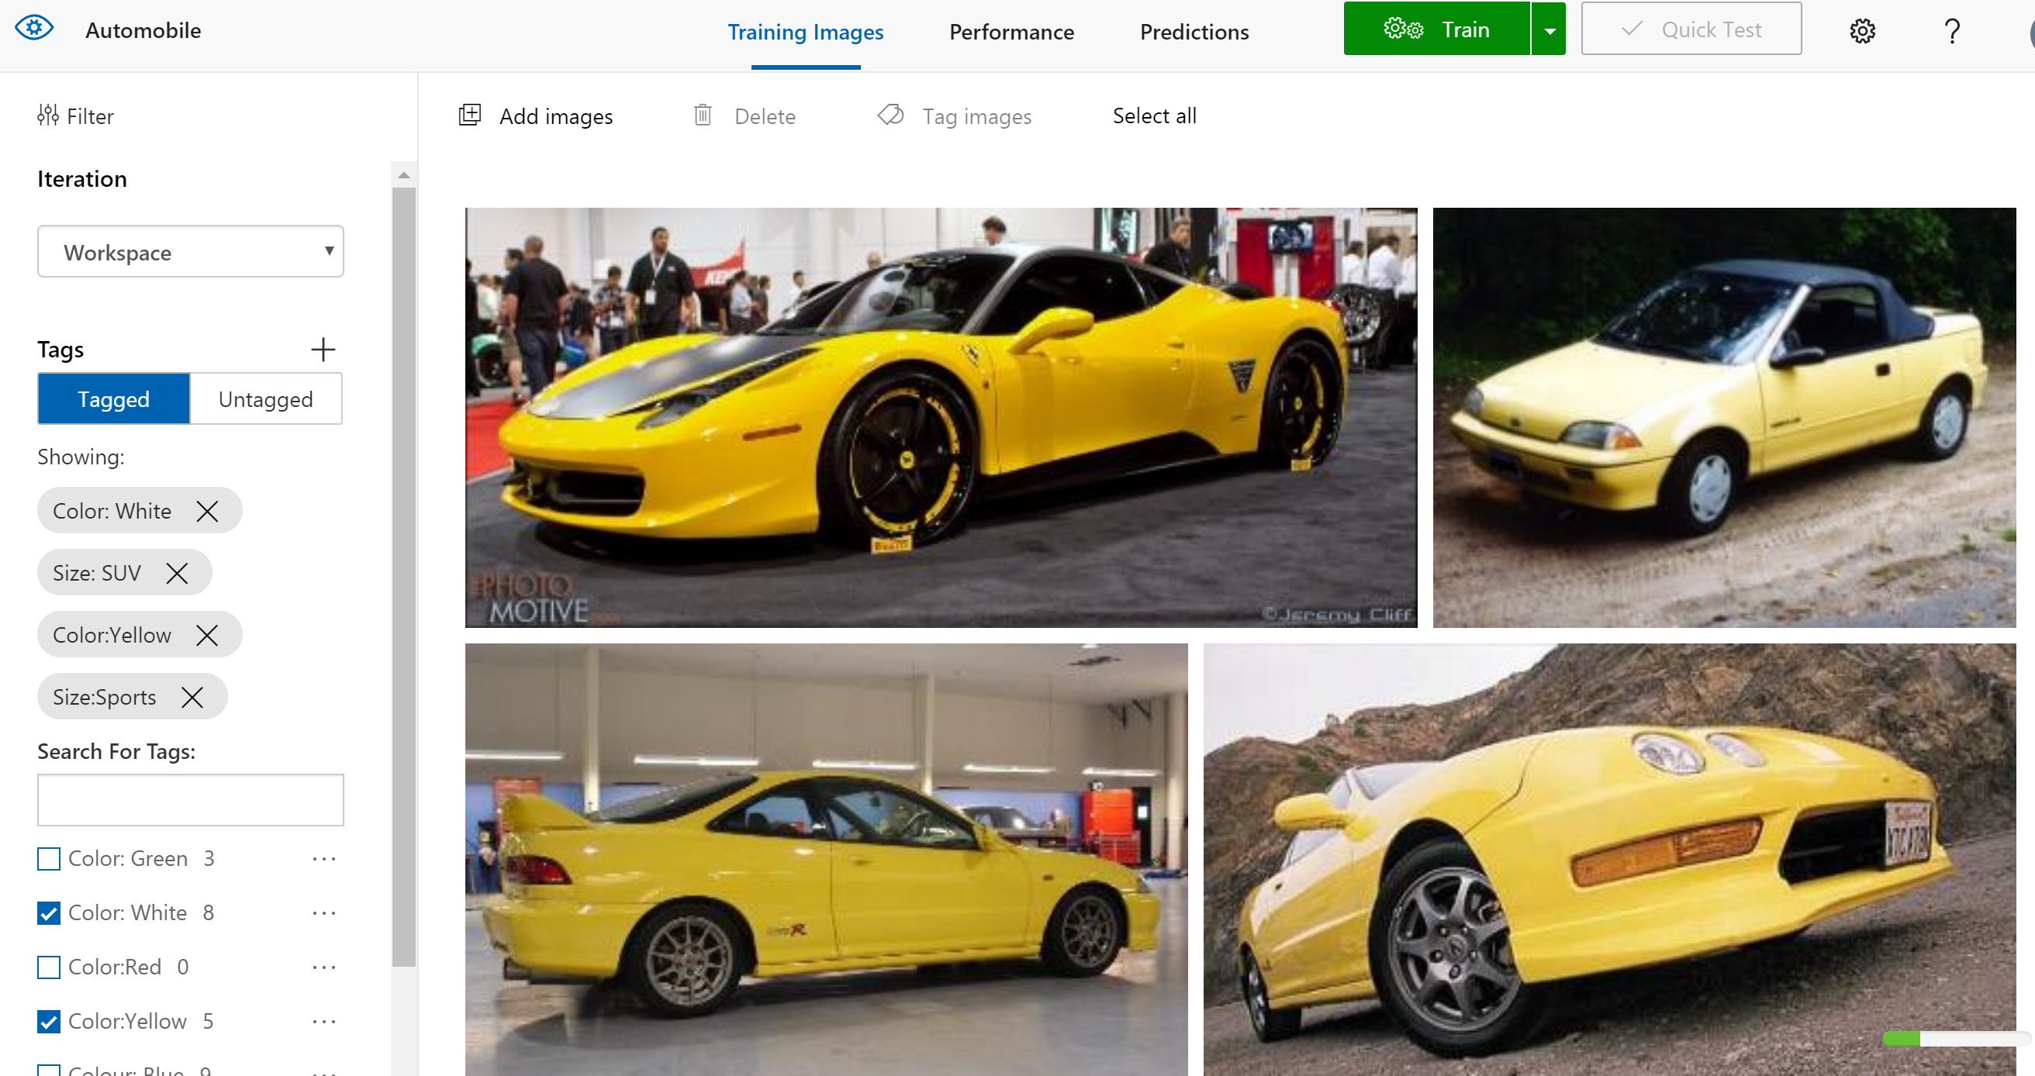

With the tagged images uploaded, the next step is to train the model with these images so it can distinguish between cars by Color, Size, and brand,

**Exercise - Train the model**

* 5 minutes

In this unit, you'll train the model using the images uploaded and tagged in the previous exercise. After you train a model, you can refine it by uploading additional tagged images and retraining it.

1. Click the **Train** button at the top of the page to train the model. Each time you train the model, a new iteration is created. The Custom Vision Service maintains several iterations, allowing you to compare your progress over time.



1. Wait for the training process to finish. (It should take only a few seconds.) Then review the training statistics presented to you for iteration 1.

The results show two measures of a model's accuracy, **Precision** and **Recall**. Suppose the model was presented with three white car images and three from green car images. Let's say it correctly identified two of the white car samples as "Color: White" images, but incorrectly identified two green car samples as “Color: White”. In this case, the **Precision** would be 50%, since it identified two out of four images correctly. The **Recall** score would be 67% since it correctly identified two of the three white car images correctly.

In the next exercise, we'll test the model using the portal's Quick Test feature, which 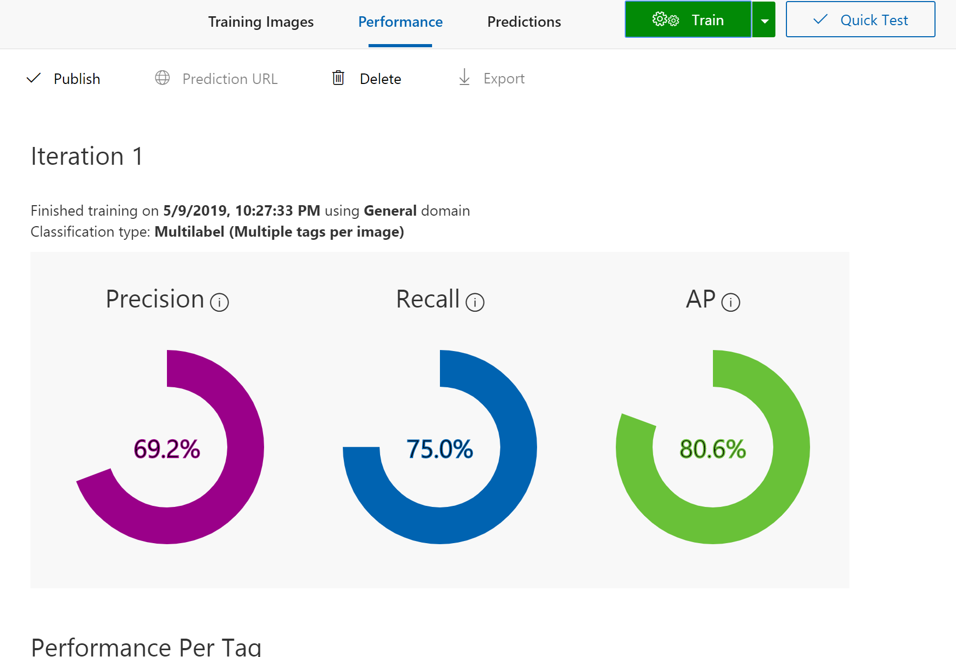allows you to submit images to the model and see how it classifies them using the knowledge gained from the training images.

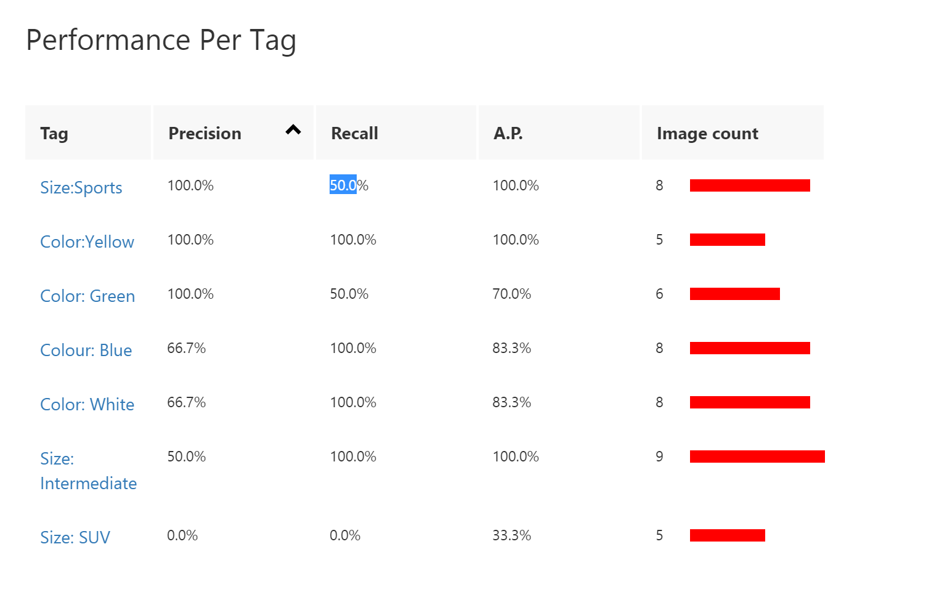

**Exercise - Test the model**

* 5 minutes

Now that we've trained our model, it's time to test it. We'll give the model new images and see how well it classifies it.

1. Click **Quick Test** at the top of the page.



1. Click **Browse local files**, and then browse to the "Quick Tests" folder in the module resources folder you download previously. Select **orange car** and click **Open**.

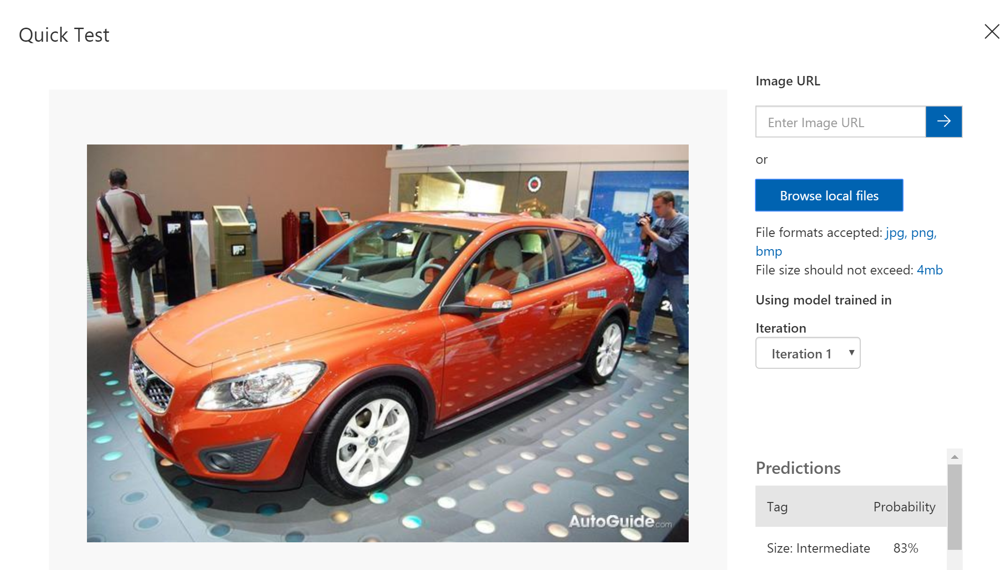

1. Examine the results of the test in the "Quick Test" dialog. What is the probability that the car is a white car? What is the probability that it's a Red or Green?
2. Close the "Quick Test" dialog. Then click **Predictions** at the top of the page.



1. Click the test image that you uploaded to show a detail of it. Then tag the image as a "Orange" by adding Orange in the list and clicking **Save and close**.

By tagging test images this way, you can refine the model without uploading additional training images.

1. 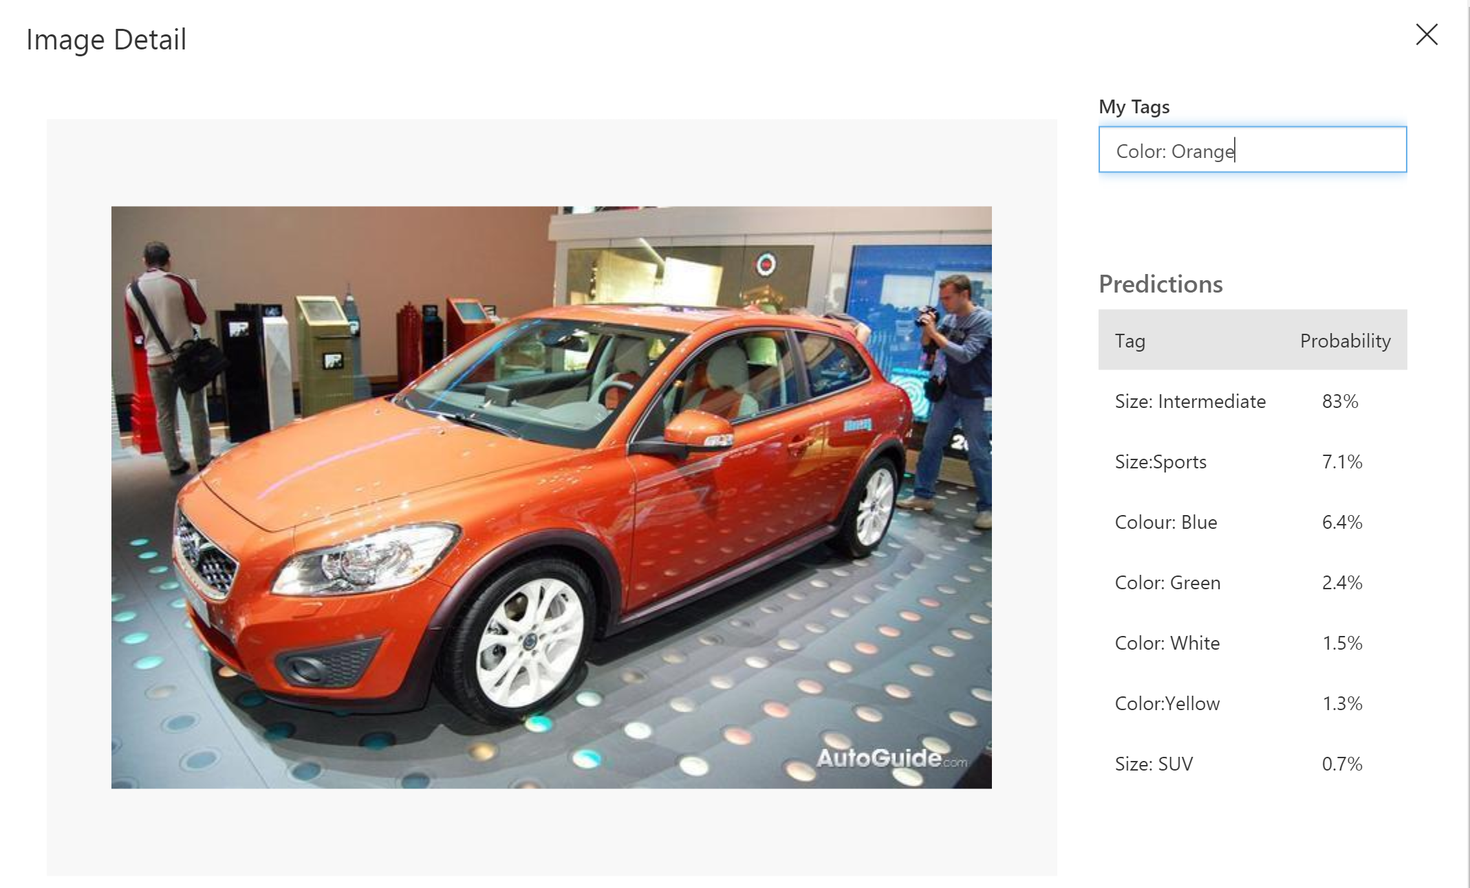

The model is trained and ready to go and appears to be skilled at identifying car by different colors. Let's call the prediction endpoint over HTTP and see what happens.

**Exercise - Call the model's prediction endpoint over HTTP Out of Scope**

* 5 minutes

This module requires a sandbox to complete. A sandbox gives you access to Azure resources. Your Azure subscription will not be charged.

[Sign in to activate sandbox](https://docs.microsoft.com/en-gb/learn/modules/classify-images-with-custom-vision-service/5-call-the-prediction-endpoint-curl?activate-azure-sandbox=true)

In the last exercise, we tested our trained model using the **Quick Test** feature of the Custom Vision Service portal. This is a great way to quickly check the accuracy of the model with some test images. Let's go a little further and make calls to the prediction endpoint of our model over HTTP.

**Note**

Make sure you activate the sandbox before you continue.

1. Returning to your **Artworks**\* project in the Custom Vision Service portal, select the **Performance** tab.



1. Select **Publish** to publish the latest iteration.
2. Select **Prediction URL**. This displays a dialog of the information we need to make our calls.

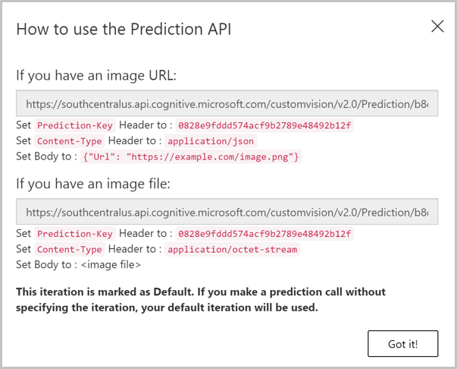

As the dialog shows, we can call the prediction endpoint and pass it an image URL. We can also pass a raw image to the endpoint in the body of the request.

Take note of three pieces of information from this dialog.

* + **Prediction-Key**: This key has to be set as a header in all requests. That's what gives us access to the endpoint.
  + **Request URL**: The dialog shows two different URLs. If we're posting an image URL, then use the first URL, which ends in /url. If we want to post a raw image in the body of our request, we use the second URL, which ends in /image.
  + **Content-Type**: If we're posting a raw image, we set the body of the request to the binary representation of the image and the content type to application/octet-stream. If we're posting an image URL, we put that as JSON in the body and set the content type to application/json.

1. Copy and save the first URL and the Prediction-Key value from the **How to use the Prediction API** dialog.

**Tip**

**cURL** is a command line tool that can be used to send or receive files. It's included with Linux, macOS, and Windows 10, and can be downloaded for most other operating systems. cURL supports numerous protocols like HTTP, HTTPS, FTP, FTPS, SFTP, LDAP, TELNET, SMTP, POP3, etc. For more information, refer to the links below:

* [**https://en.wikipedia.org/wiki/CURL**](https://en.wikipedia.org/wiki/CURL)
* [**https://curl.haxx.se/docs/**](https://curl.haxx.se/docs/)

cURL is already installed in the Azure Cloud Shell in the sandbox. So, we'll cURL in this exercise to make HTTP calls to our endpoint.

1. Execute the following command in the Cloud Shell. Replace **[endpoint-URL]**with the URL you saved from the last step. Replace **[Prediction-Key]** with the value of Prediction-Key you saved from the last step.

Azure CLICopy

curl [endpoint-URL] \

-H "Prediction-Key: [Prediction-Key]" \

-H "Content-Type: application/json" \

-d "{'url' : 'https://raw.githubusercontent.com/MicrosoftDocs/mslearn-classify-images-with-the-custom-vision-service/master/test-images/VanGoghTest_02.jpg'}" \

| jq '.'

When the command completes, you'll see a JSON response similar to the following screenshot. The API returns a probability for every tag in the model. As you can see, with a probability close to 1 for the "painting"**tagName** value, this image is definitely a painting. However, it's not a painting by any of the artists with which we trained our model.

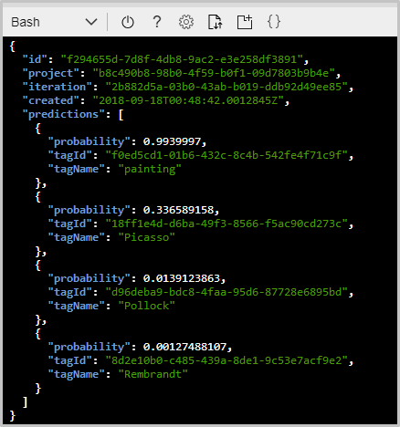

1. Try more predictions by replacing the URL in the request body above, with the URLs in the following table.

| **Image** | **URL** |
| --- | --- |
| Thumbnail of test picasso image | https://raw.githubusercontent.com/MicrosoftDocs/mslearn-classify-images-with-the-custom-vision-service/master/test-images/PicassoTest_02.jpg |
| Thumbnail of test rembrandt image | https://raw.githubusercontent.com/MicrosoftDocs/mslearn-classify-images-with-the-custom-vision-service/master/test-images/RembrandtTest_01.jpg |
| Thumbnail of test pollock image | https://raw.githubusercontent.com/MicrosoftDocs/mslearn-classify-images-with-the-custom-vision-service/master/test-images/PollockTest_01.jpg |

Our prediction endpoint is working as expected. Calling the API is as simple as making a HTTP request to the endpoint with a Prediction-Key and an image URL.

**Summary and knowledge check**

* 10 minutes

Image classification is playing an increasingly large role in industry as a means for automating such tasks as checking images uploaded to web sites for offensive content and inspecting parts rolling off assembly lines for defects. Building an image-classification model manually — that is, coding it from the ground up in Python, R, or another language — is costly and requires expertise. The Custom Vision Service enables virtually anyone to build sophisticated image-classification models. And once a model is built and trained, an app that uses it is only few lines of code away.

**Check your knowledge**

Top of Form

1.

When creating a new Custom Vision Service project, what is a domain used for?



Helps you decide what to name your project.



Helps you decide how to structure your project.



Optimizes the classifier for a specific image type.

2.

Why should you add a tag after uploading images?



To help you organize your images in the project for later use



To put the images in a category for training



To generate a word cloud after training

3.

What two values do you need to know in order to make a call to the Prediction API from client code?



Prediction URL and Prediction Key



Service name and authentication token



Client secret and redirect URI

Check your answers